**Day3 (26.10.24)**

**Test 1:**

1. Write a Java program to calculate the area of the Triangle.

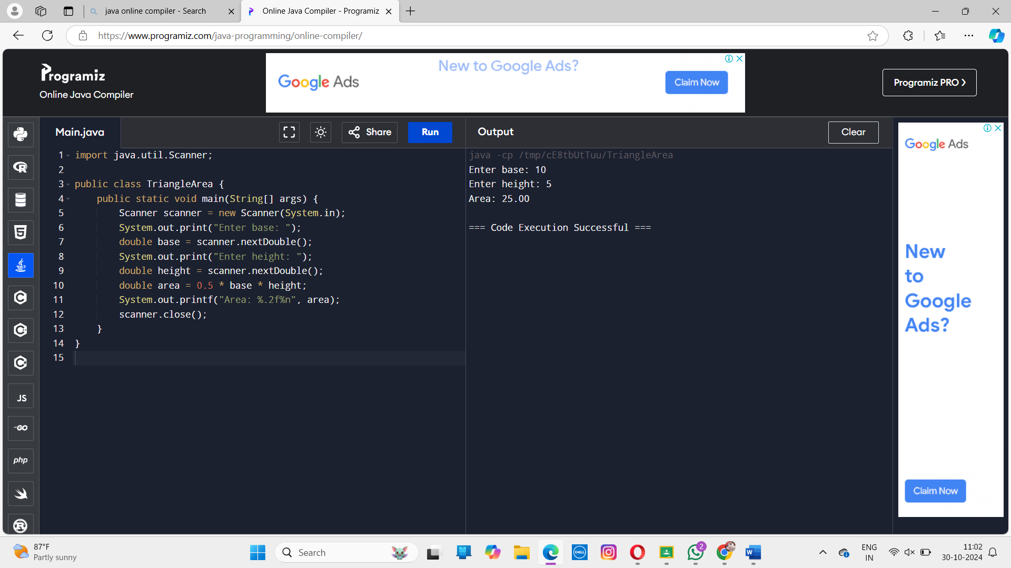

1. Write a Java program to calculate the area of the Circle.

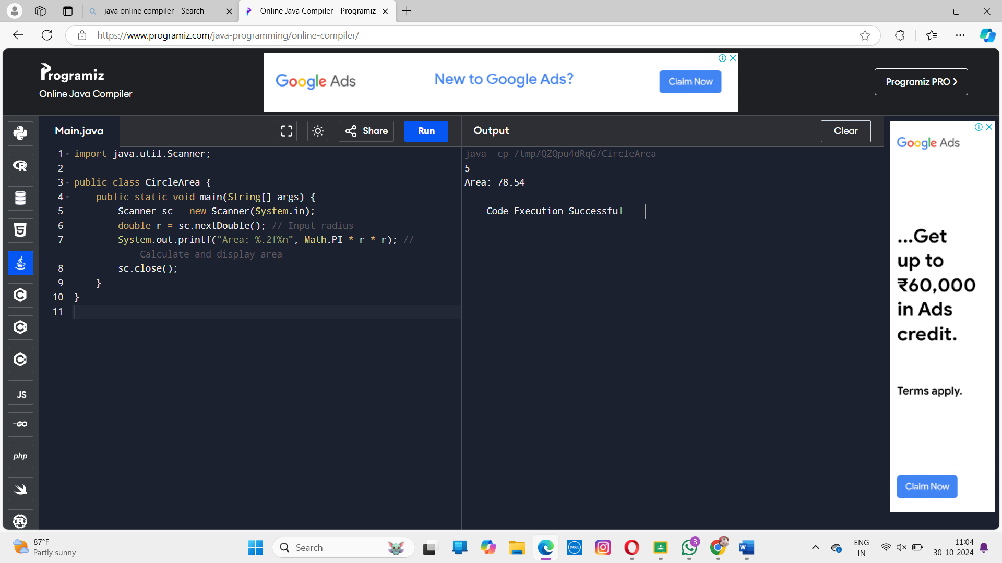

1. Write a Java program to interchange two values without using temporary variable.

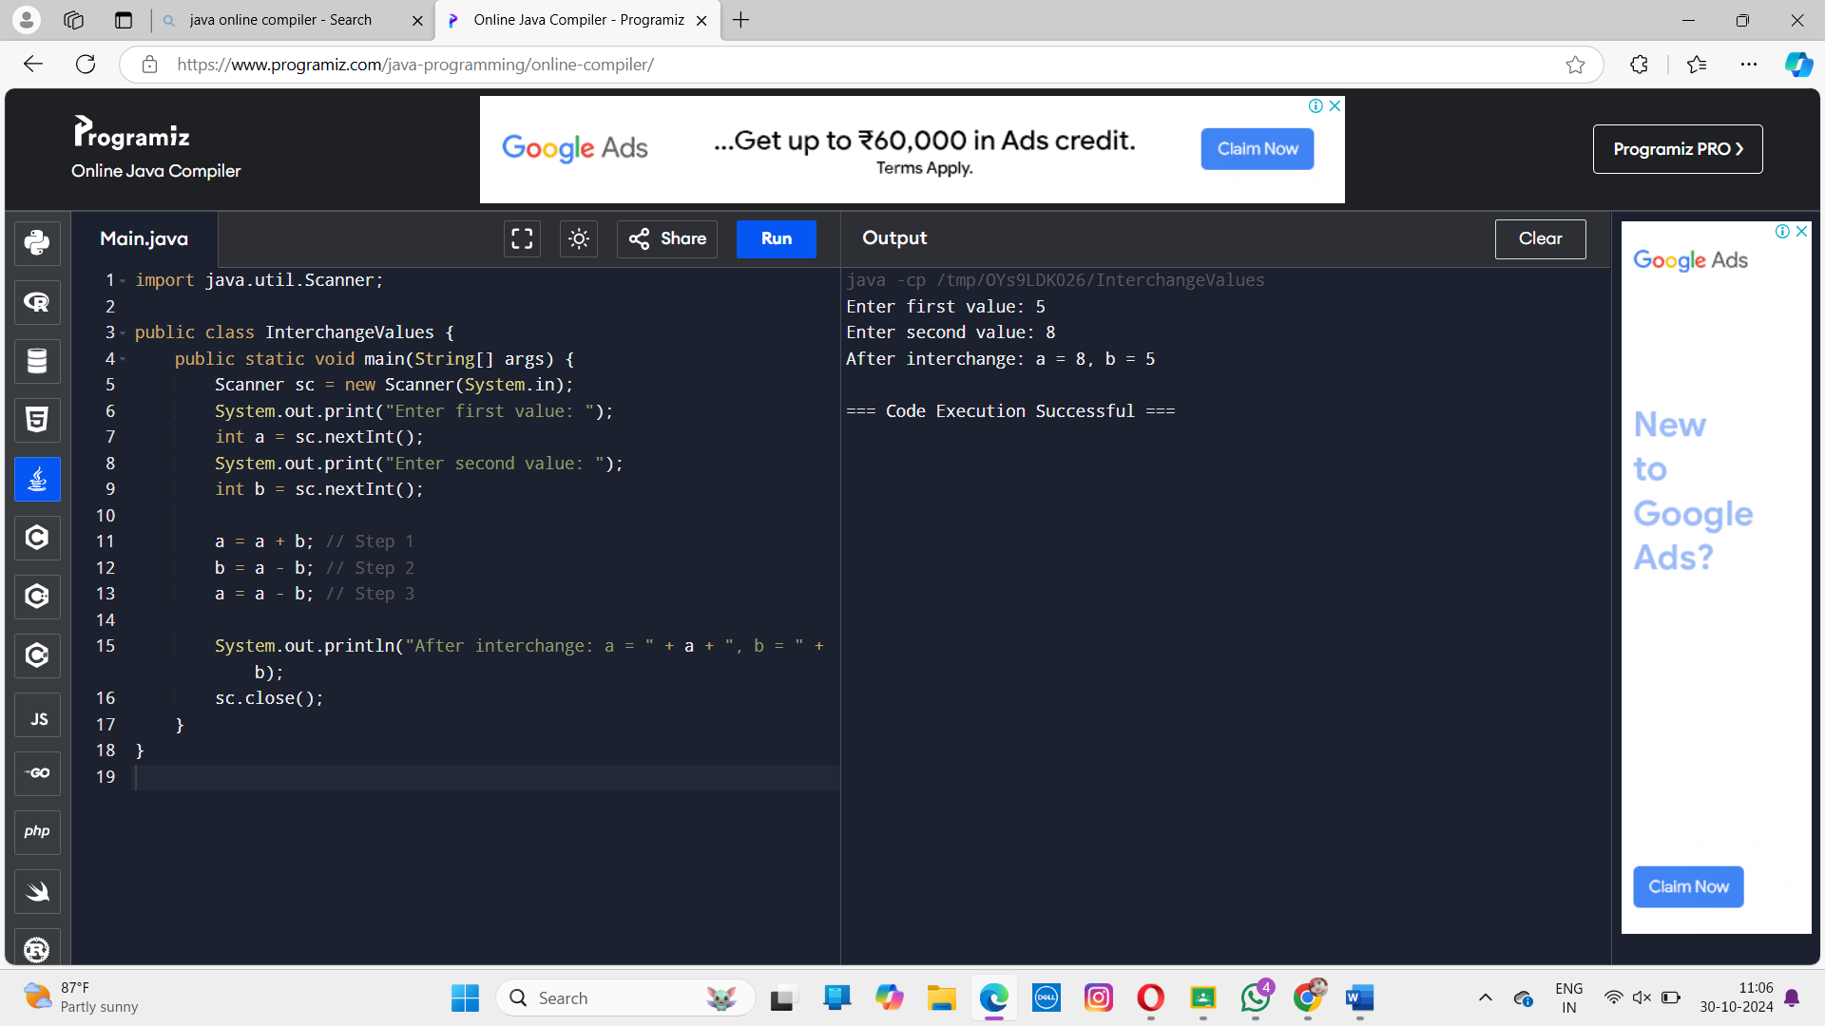

1. Write a Java program to calculate the Simple Interest.

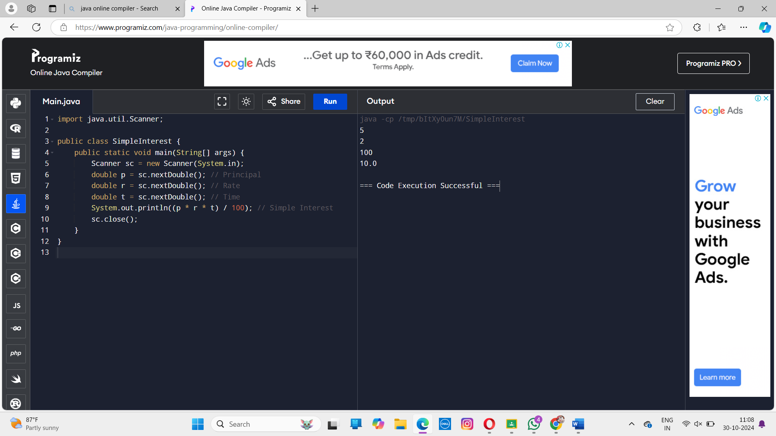

**Assignment 3**

1. Write a Java program to display your Register Number, Name, Course Code, Course Name and Test1 Mark using run time input.

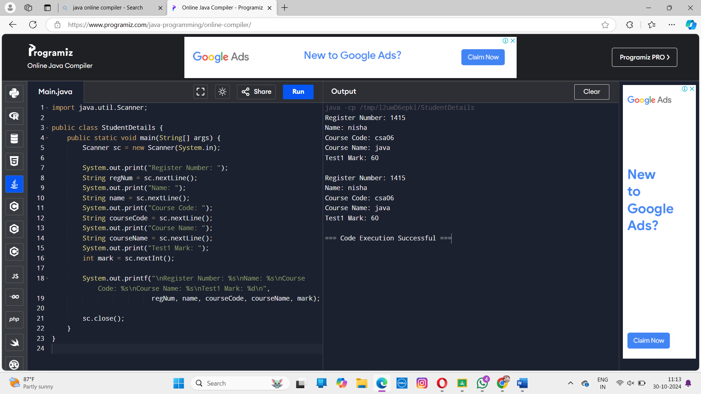

1. Write a Java program to calculate the Volume of Sphere using run time input

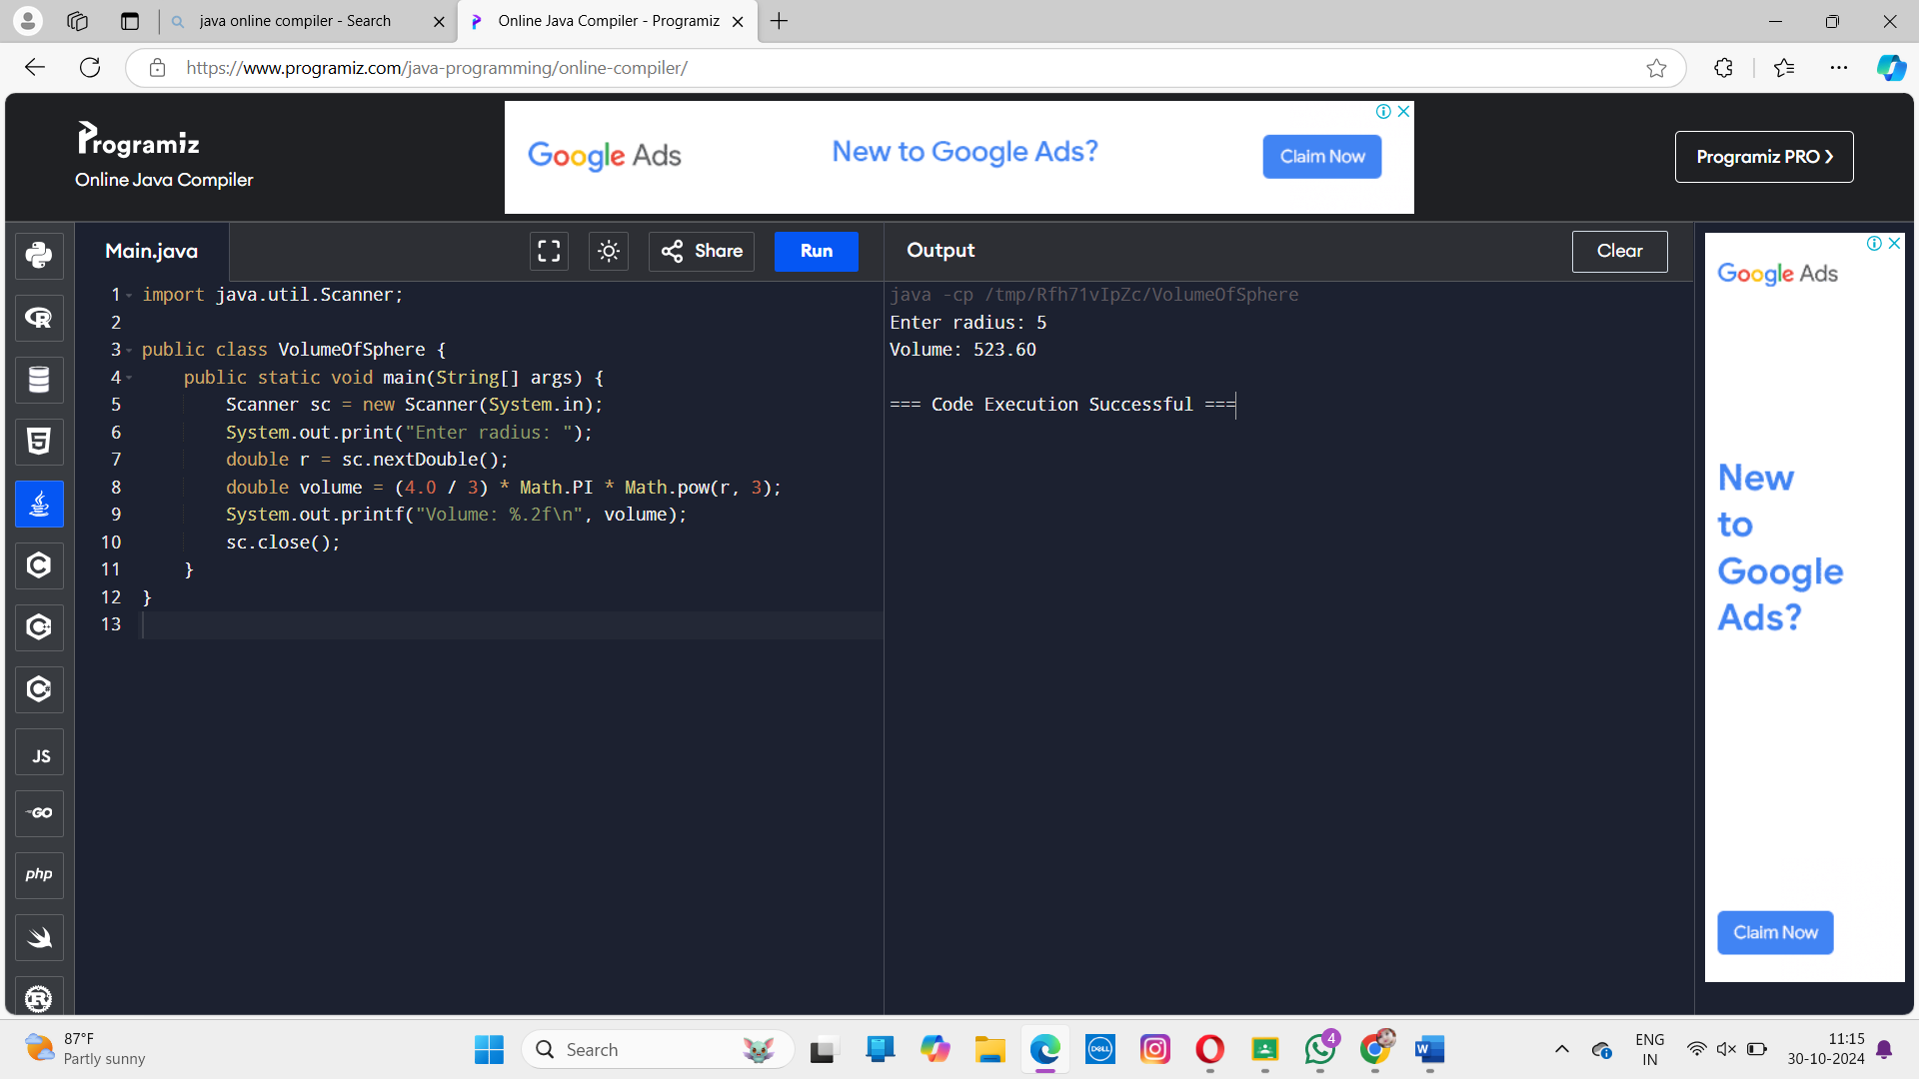

3. Write a Java program to find the following

a) Power(5, 6) b) Sqrt(45) c) Log(1)

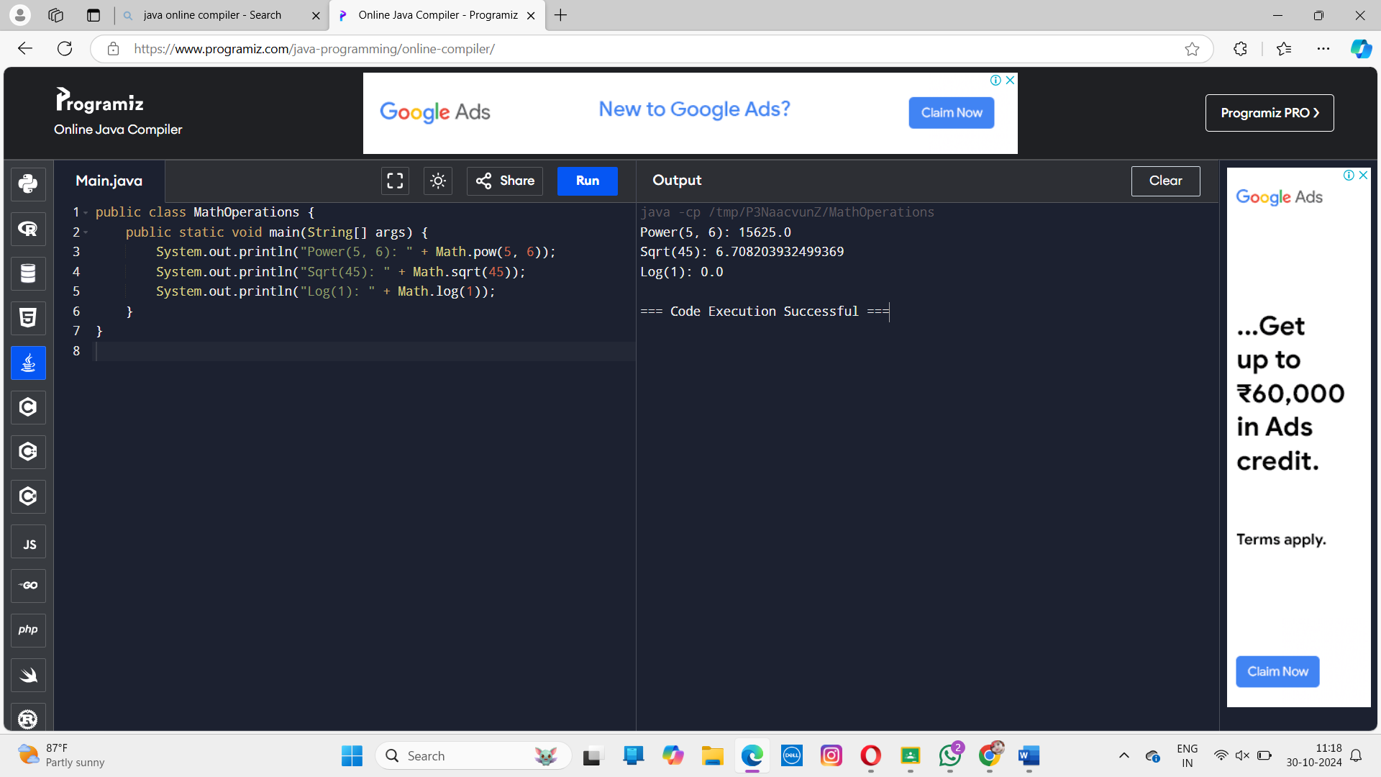

4.Write a Java program to calculate the given expression

Double d=56.778,Int I=20,Float f=10.5

Int X,X=d+I+f,Find the X value

